Life Cycle Plan (LCP)

LINGGGO

Team 3

Chicheng Ren – Software Architect
Dahai Li – Quality Focal Point
Dashun Wen – Life Cycle Planner
Kraingkrai Bumroungruksa –Feasibility Analyst
Siming Ye – Operational Concept Engineer
Shiqi Wei – Prototyper
Yiting Xiao – Project Manager

Version History
Date | Author | Version | Changes made | Rationale
10/11/15 | WDS | 1.0 | Original template for use with LINGGGO v1.0 | Initial draft for use with LINGGGO v1.0
10/19/15 | CCR, YX | 1.1 | Redo Cost Estimation | Cost Estimation using COCOMOII
11/24 | YX | 1.2 | Add Chapter 6  Modify milestones | Finish Iteration Plan

Table of Contents
Life Cycle Plan (LCP) i
Version History ii
Table of Contents iii
Table of Tables iv
Table of Figures 1
1. Introduction 2
1.1 Purpose of the LCP 2
1.2 Status of the LCP 2
2. Milestones and Products 3
2.1 Overall Strategy 3
2.2 Project Deliverables 3
3. Responsibilities 6
3.1 Project-specific stakeholder’s responsibilities 6
3.2 Responsibilities by Phase 8
3.3 Skills 8
4. Approach 9
4.1 Monitoring and Control 9
4.2 Methods, Tools and Facilities 9
5. Resources 10
6. Iteration Plan (Not required) 17
6.1 Plan 17
6.1.1 Capabilities to be implemented 17
6.1.2 Capabilities to be tested 17
6.1.3 Capabilities not to be tested 18
6.1.4 CCD Preparation Plans 18
6.2 Iteration Assessment 18
6.2.1 Capabilities Implemented, Tested, and Results 18
6.2.2 Core Capabilities Drive-Through Results 18
6.3 Adherence to Plan 19

Table of Tables
Table 1: Artifacts Deliverables in Exploration Phase 3
Table 2：Artifact deliverable in Valuation Phase 4
Table 3：Artifact deliverable in Foundations Phase 5
Table 4：Artifact deliverable in Development Phase 5
Table 5：Stakeholder's Responsibilities in each phase (See next page) 6
Table 6：COCOMOII Scale Driver 10
Table 7：COCOMOII Cost Driver – Match System 11
Table 13: Construction iteration capabilities to be implemented 17
Table 14: Construction iteration capabilities to be tested 17
Table 15: Capabilities implemented, tested, and results 18

Table of Figures
Figure 1: Scale Factors 11
Figure 2: EAF-Match System 13
Figure 3: EAF-Profile Management System 15
Figure 4: EAF-Message System 17
Figure 5: Total Estimation 17

    - Introduction

Purpose of the LCP
The purpose of this document is to give a statement of duration, technology, teamwork and main goal of LINGGGO project and to clearly define and plan the processes, milestones, responsibilities, and deliverables for the LINGGGO project.

Status of the LCP
The status of the LCP is currently at the version number 1.0. The latest version of this document will be delivered to the client.

The duration of the project is 16 weeks in 2015 Fall.
    - Milestones and Products

Overall Strategy
The LINGGGO is following Architected Agile process because there is no Non-Development Item or Web service that would fit to most of the core capabilities.

Exploration phase
Duration: 08/20/15-9/4/15
Concept: Identify operation concept, client requirements and user need.
Deliverables: Client Interaction Report
Milestone: Valuation Commitment Review

Valuation phase
Duration: 09/24/15-9/30/15
Concept: Identify objectives, constraints and priorities, Design draft prototype, Provide feasibility evidence, prepare management plan.
Deliverables: Draft Foundations Commitment Package
Milestone: Foundations Commitment Review

Foundation phase
Duration: 10/1/15-10/19/15
Concept: Assess Project status, project management plan, project quality, prototype. Design software Architect.
Deliverables: Development Commitment Package
Milestone: Development Commitment Review

Development phase
Duration: 10/19/15-11/19/15
Concept: Development of all systems and modules.
Deliverables: Fully functionalized website.
Milestone: Client Acceptance Review

Test phase
Duration: 11/20/15-11/30/15
Concept: Quality assurance from test team.
Deliverables: Test Case Result.
Milestone: One test cycle.

Transition phase
Duration: 12/1/15-12/5/15
Concept: Transit all project relate things to client
Deliverables: As-built package; code; server
Milestone: End of project

Project Deliverables

Exploration Phase
Table 1: Artifacts Deliverables in Exploration Phase
Artifact | Due date | Format | Medium
Client Interaction Report | 9/28 | .pdf | Soft copy
Top risk presentation | 10/2 | .pdf | Soft copy
Win condition Report | 9/28 | .pdf | Soft copy
Progress Report | Biweekly Wednesday | .xls | Soft copy
Project Plan | Biweekly Wednesday | .mpp | Soft copy
Jira Report | Every Monday | Jira | Soft copy
Risk and Defect | Biweekly Wednesday | .xls | Soft copy

Valuation Phase

Table 2：Artifact deliverable in Valuation Phase
Artifact | Due date | Format | Medium
Draft Foundation Commitment Package  - Operational Concept Description (OCD)  - Life Cycle Plan (LCP)  - Feasibility Evidence Description (FED) Section 1-5  - Prototype Report  - Life Cycle Plan (LCP) Section 1 -5  - System and Software Architecture (SSAD) | 10/13 | .doc .pdf | Soft copy
Foundation Commitment Package  - Operational Concept Description (OCD)  - Life Cycle Plan (LCP)  - Feasibility Evidence Description (FED) Section 1-5  - Prototype Report  - Life Cycle Plan (LCP) Section 1 -5  - System and Software Architecture (SSAD) | 10/19 | .doc .pdf | Soft copy
Progress Report | Biweekly Wednesday | .xls | Soft copy
Project Plan | Biweekly Wednesday | .mpp | Soft copy
Jira Report | Every Monday | Jira | Soft copy
Risk and Defect | Biweekly Wednesday | .xls | Soft copy

Foundations Phase

Table 3：Artifact deliverable in Foundations Phase
Artifact | Due date | Format | Medium
Progress Report | Biweekly Wednesday | .xls | Soft copy
Project Plan | Biweekly Wednesday | .mpp | Soft copy
Jira Report | Every Monday | Jira | Soft copy
Risk and Defect | Biweekly Wednesday | .xls | Soft copy

Development Phase

Table 4：Artifact deliverable in Development Phase
Artifact | Due date | Format | Medium
Progress Report | Biweekly Wednesday | .xls | Soft copy
Project Plan | Biweekly Wednesday | .mpp | Soft copy
Jira Report | Every Monday | Jira | Soft copy
Risk and Defect | Biweekly Wednesday | .xls | Soft copy

    - Responsibilities

Project-specific stakeholder’s responsibilities

Our project-specific stakeholders (other than the typical stakeholders of CSCI577a) are Zsuzsa Londe as the project owner and Ajay Rai as the project technological director.

Table 5：Stakeholder's Responsibilities in each phase (See next page)

Team Member / Role | Primary / Secondary Responsibility
  Primary Responsibility
 | Exploration | Valuation | Foundations | Development- Construction Iteration | Development- Transition Iteration
Name: Zuzsa Londe  Role: Project Owner | Primary Responsibility  Business workflow  Secondary Responsibility  Provide initial goal and scope for LINGGGO | Primary Responsibility  Evaluate project | Primary Responsibility  Provide feedback and review on progress. | Primary Responsibility  Review website and help test. | Primary Responsibility  Review website and help test.
Name: Ajay Rai  Role: Technological Director | Give technical advice and being as technical supervisor in LINGGGO | Evaluate project from technical perspective | Give advice about technology | Review website from technical perspective. | Give instruction to technical support
Name: Chicheng Ren  Role: Software Architect/ Programmer | Draft design the architecture of the project | Create LINGGGO prototype | Create LINGGGO back end demo and primary API. | Implement LINGGGO back end.  Fix bugs. | Trainer.  Tester
Name: Dahai Li  Role: Quality Focal Point/Tester | Observe and provide advice for team collaboration. | Design test case and project quality control plan. Team document review. | Write test case and unit test to test on technical prototype and demo | Write test case. Report bugs. Verify fixed bugs and close bugs. | Write test case. Report bugs. Verify fixed bugs and close bugs.
Name: Dashun Wen  Role: Life Cycle Planner/Tester | Design and discuss about life cycle plan. | Decide LCP content. | Help Dahai write test case and unit test. | Write test case. Report bugs. Verify fixed bugs and close bugs. | Write test case. Report bugs. Verify fixed bugs and close bugs.
Name: Kraingkrai Bumroungruksa  Role: Feasibility Analyst/ Programmer | Design and discuss about feasibility evidence analysis. | Decide Project Feasibility Analyst strategy. | Create LINGGGO back end demo and primary API. | Implement LINGGGO back end.  Fix bugs. | Implement LINGGGO back end.  Fix bugs.
Name: Siming Ye  Role: Operational Concept Engineer/Programmer | Negotiation with clients, collect and summarize for OCD. | Complete OCD diagram and confirm with whole team. | Help create LINGGGO front end and back end demo | Implement LINGGGO front end.  Fix bugs. | Implement LINGGGO front end.  Fix bugs.
Name: Shiqi Wei  Role: Prototyper/Programmer | Help with prototype design | Help project manager manage project time. Help create prototype. | Create LINGGGO back end demo and primary API. | Implement LINGGGO back end.  Fix bugs. | Implement LINGGGO back end.  Fix bugs.
Name: Yiting Xiao  Role: Project Manager/Prototyper/ Programmer | Project control. Team role identification.  Project control and assignment allocation. | Create prototype. Design front-end demo and structure.  Project control and assignment allocation. | Create front-end prototype. Design front end file structure. Allocate front-end code assignments. | Implement LINGGGO front end.  Fix bugs. | Implement LINGGGO front end.  Fix bugs.

Responsibilities by Phase

Skills

Team members | Role | Skills
Chicheng Ren | Software Architect | PHP, MySQL Data, Linux Server, Prototype, JavaScript, Python
Dahai Li | Quality Focal Point | Java, Test, MySQL
Dashun Wen | Life Cycle Planner | C++;  JavaScript
Kraingkrai Bumroungrukas | Feasibility Analyst | PHP, MySQL Data, Linux Server, Prototype, JavaScript, Git
Siming Ye | Operational Concept Engineer | PHP, Code Igniter, JavaScript;  Angular JS
Shiqi Wei | Operational Concepts Engineer | C++, Java, MySQL, Open CV,JSP; PHP, Code Igniter
Yiting Xiao | Project Manager | JavaScript, Angular JS, PHP, Git, Prototype

    - Approach

Monitoring and Control
Progress Reports are used to track the weekly progress. Jira is used to track bugs and issues that happens during progress. Winbook is used for tracking requirements.

Closed Loop Feedback Control

The team is using Gmail and Wechat group as primary communication method. Google drive is used as the primary method for updated files and documentations.

Reviews
The DEN student on the team is observing and providing feedback for teams during collaboration. In addition, he is experienced in industry so he could provide reliable quality management. Besides, one of our client have strong technical background so that he can provide feedback and advice when we present our functional demo and navigational UI prototype.

Methods, Tools and Facilities

Tools | Usage | Provider
Winbook | This tool assists in managing winwin conditions that represent the requirements of all success stakeholders and helps us prioritize the features we will develop | USC
Jira | Jira help track bugs in the system and log work-hours spent on the project | USC
Github | Git is a code version control system which allows us to commit and merge the most recently updated code with each other and also helps track the changes made to the code | Github
Google Drive | Google drive helps our team to manage documentation | Google
PHP | Website development | Open source
MYSQL | Database | Open source
AWS | Provide web service | Amazon
Angular JS | Building the website | Open source
Code Igniter | Web framework | Open source

Resources

Identify the following information in order to estimate the software cost:
- Estimated CSCI577a Effort : 7 team members at 20 hrs/week for 13 weeks
- Total estimated effort: 1824 hr
- Budget information: $ 0
- Project duration: 12 weeks
- Component modules in your development project: Match System, Profile Management System, Message System.
- Programming language used: HTML, JavaScript, PHP, MySQL.

Table 6：COCOMOII Scale Driver
Scale Driver | Value | Rationale
PREC | Low | There is no past system, so it is a new system.  Our team members have no much experience on creating a user (Language Learner) matching system.
FLEX | Nominal | Our client has some requirements but also willing negotiate on the minimal marketable features
RESL | Nominal | We routinely hold meetings and use prototypes to strengthen cohesion of the project with the whole team, so primary risks could be mitigated. However, due to the lack of experience we still may have some risk that is difficult to mitigate.
TEAM | HIGH | Meet with the client every week and discuss about the changes and improvement of the project.
PMAT | Nominal | Based on CMN and KPA assessment, our team is in CMN Level 2, which give us rate as nominal.

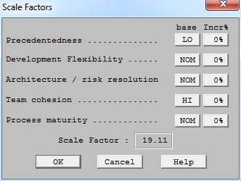
Figure 1: Scale Factors

Table 7：COCOMOII Cost Driver – Match System
Cost Driver | Value | Rationale
RELY | High | If the system is not working, all Language Learners are prevented from matching.
DATA | Low | The match system does not store any data
DOCU | High | All documents will match life cycle. Since our system is using RESTful API, we must provide sufficient document for future developers.
CPLX | High | Since match system shall search between different tables in database and satisfy different search conditions such as filter, it is high complexity.
RUSE | High | Match system will be extended for iOS, android in future.
TIME | Nominal | Since there is no special deadline for release. It’s nominal.
STOR | Nominal | No special constrain on storage resources.
PVOL | Low | Match system are mainly web based.
ACAP | Nominal | Our team has capability to discuss and discover client requirements and communication. But lack of capability of design large data based API and database.
PCAP | Nominal | Four members in our team have experience with web application development.
PCON | Low | All team member are only one semester.
APEX | Nominal | Four of team members have experience on course-project level web application.
LTEX | Nominal | Four have experience on PHP. Four have experience JavaScript.
PLEX | Nominal | Two of us have linux and apache server configuration experience.
TOOL | Nominal | Only two of us have experience on Github. Others all need training.
SITE | High | Only one team member live in different city. However we communicate by phone, message, email, Skype, so it is almost the same as on campus student.

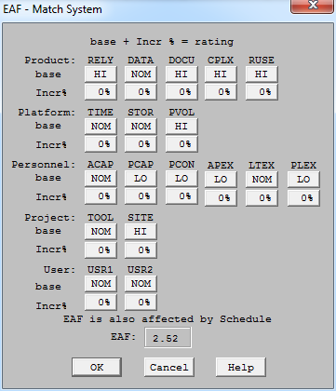
Figure 2: EAF-Match System

Table 8：COCOMOII Cost Driver – Profile Management System
Cost Driver | Value | Rationale
RELY | High | If the system is not working, all Language Learners are prevented from login and profile management.
DATA | Nominal | If the number of Language Learners is increased, it may affect the system.
DOCU | Low | Not too many API need documentation.
CPLX | Low | System receives user (Language Learner) account information as input and display as output.
RUSE | Nominal | Profile management system will be extended for iOS, android in future.
TIME | Nominal | Since there is no special deadline for release. It’s nominal.
STOR | Nominal | No special constrain on storage resources.
PVOL | Low | Profile management system is basically used in web.
ACAP | High | Our client has capability to determine on what features we need for user(Language Learner) account management.
PCAP | Nominal | Four members in our team have experience with web application development.
PCON | Low | All team member are only one semester.
APEX | Nominal | Four of team members have experience on course-project level web application.
LTEX | Nominal | Four have experience on PHP. Four have experience JavaScript.
PLEX | Nominal | Two of us have linux and apache server configuration experience.
TOOL | Nominal | Only two of us have experience on Github. Others all need training.
SITE | High | Only one team member live in different city. However we communicate by phone, message, email, Skype, so it is almost the same as on campus student.

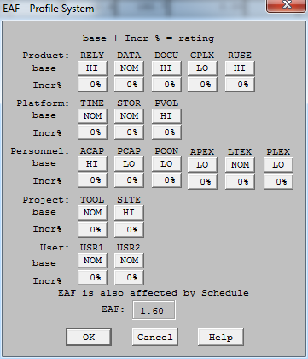
Figure 3: EAF-Profile Management System

Table 9：COCOMOII Cost Driver – Message System
Cost Driver | Value | Rationale
RELY | High | If the system is not working, all Language Learners are prevented from sending message. Language Learners may not be able to retrieve existing messages; however, message will not disappear from the system.
DATA | High | Message number can be rapidly increased as Language Learners sends and receives more messages.
DOCU | High | All documents will match life cycle. Since our system is using RESTful API, we must provide sufficient document for future developers.
CPLX | Nominal | Messages that a Language Learner sends and receives are stored in server database so it is not difficult to design and implement. New message notification, time stamp, and refresh strategy may be a little complex.
RUSE | High | Message management system will be extended for iOS, android in future.
TIME | Nominal | Since there is no special deadline for release. It’s nominal.
STOR | High | There should be a upper bound for the number of messages since the server has limited storage.
PVOL | High | Profile management system shall be used for all platforms and all devices.
ACAP | Nominal | None of us has experience on message system, so we need to learn from other mature message system.
PCAP | Nominal | Four members in our team have experience with web application development.
PCON | Low | All team member are only one semester.
APEX | Nominal | Four of team members have experience on course-project level web application.
LTEX | Nominal | Four have experience on PHP. Four have experience JavaScript.
PLEX | Nominal | Two of us have linux and apache server configuration experience.
TOOL | Nominal | Only two of us have experience on Github. Others all need training.
SITE | High | Only one team member live in different city. However we communicate by phone, message, email, Skype, so it is almost the same as on campus student.
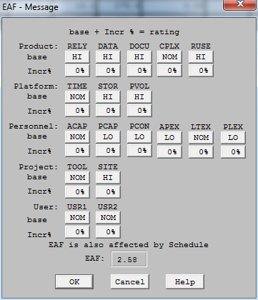
Figure 4: EAF-Message System

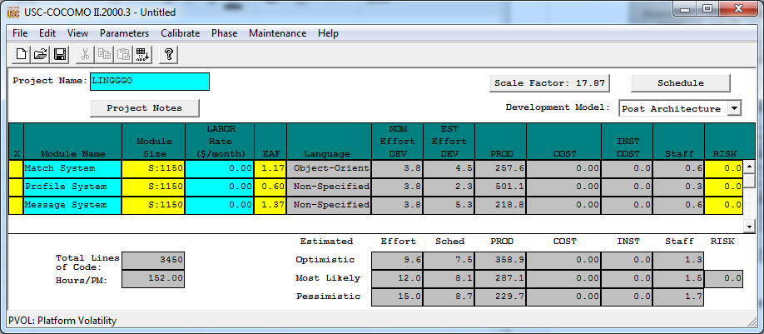
Figure 5: Total Estimation

So the COCOMOII Esitmation:
152 * 12.0 = 1824 hr

Human Estimation:
- 7 team members at 4 hours a day for 65.4 days.
- Assume there are 20 working days in months.
- Almost three months.

6. Iteration Plan

6.1 Plan
The construction iteration of the Development phase will be divided into two phases. The first phase contains three paralleled iterations while the second phase is a two round combined iterations.
For the first phase, the three iterations are Match System, Profile System, Message System. During this three iteration, the core capability will be finished development separately. If one sub-system depends on other system, use dummy data to finish the core capability. For the second phase, cross sub-system function will be finished during the first iteration. The second iteration will be the develop as whole to modify display and user experience and fix bugs.

6.1.1 Capabilities to be implemented
Table 8: Construction iteration capabilities to be implemented
ID | Capability | Description | Priority | Iteration
1 | OC-1 | Match System | High | 1-1, 2, 3
2 | OC-2 | Profile Management System | High | 1-2, 2, 3
3 | OC-3 | Message System | High | 1-3, 2, 3

6.1.2 Capabilities to be tested
Table 9: Construction iteration capabilities to be tested
ID | Capability | Description | Priority | Iteration
1 | OC-1 | Match System | High | 3
2 | OC-2 | Profile Management System | High | 3
3 | OC-3 | Message System | High | 3

6.1.3 Capabilities not to be tested
None. All OC are supposed to be tested.

6.1.4 CCD Preparation Plans
Our clients will be involved in the CCD. The development team will send a link that an be access with Internet. The client will use our website and finish certain tasks in the system such as create a account, find a language learner and send a message to him or her. The database are pre-populated so that the search functionality can work properly with dummy test user data.

6.2 Iteration Assessment

6.2.1 Capabilities Implemented, Tested, and Results
Table 10: Capabilities implemented, tested, and results
ID | Capability | Test Case | Test Results | If fail, why?
OC-1 | Match System | TC-05 | Pass
OC-2 | Profile Management System | TC-01 | Partially Pass | Need Validation for some field; need be consistent with backend validation
OC-2 | Profile Management System | TC-02 | Pass
OC-2 | Profile Management System | TC-03 | Partially Pass | If a user token is expired, the user can not be automatically log off.
OC-2 | Profile Management System | TC-04 | Pass
OC-3 | Message System | TC-06 | Pass

6.2.2 Core Capabilities Drive-Through Results
Sign up an account
The client was pleased with the overall design. But she wanted the fields order to be changed. Also she wanted the “University” label change into “University/School”. She found the US should be on the top of the list of Country selection. After she fail to register, she does not like the pop up alert message window. After she successfully signed up for an account, she expected it should jump somewhere to the next flow, but the page stayed. So she felt confused.

Login with an account
She forgot about her password immediately after she signed up for an account.

Match for a language learner
She is satisfied with the match function and match result page. But she expected the signed in user have a default language selected.

Send a message to a language learner
She thought the delete function are not necessary in message-list page.

Change the profile picture/information
She wanted the native skill and desired skill combine together as one tab.

Also she wanted a “How it works” button in dummy in the homepage to tell user how to use this website.

6.3 Adherence to Plan
The iterations are running on time and on budget as plan. Although there are some mistakes that happened during development process such as merge code conflict before deadline of an iteration, teammate disappear for onsite interview and delay his work for delivery. But we solved these problems by reassigned teammates with cross tasks since our teammates have multiple language skills. Therefore, we finished our development and iteration on time and on budget.

